|  |  |  |
| --- | --- | --- |
| *n | Pto Retorno *n | Cuentas: |
|  | EE *n |
|  | ED *n |
|  |  |
|  |  |
|  |  |
|  |  |
|  | VR |

|  |  |  |
| --- | --- | --- |
| *1 | Currentt | Cuentas: |
|  | Free |
|  | EE |
|  | ED |
|  |  |
|  |  |
|  |  |
|  | VR |

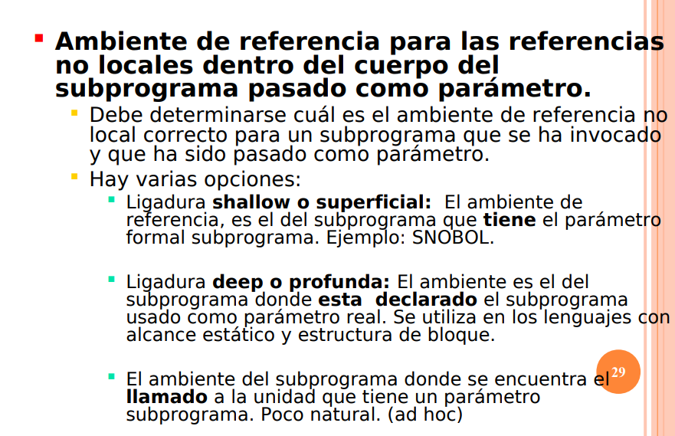

Shallow dinámico Deep estático

|  |  |  |  |  |
| --- | --- | --- | --- | --- |
| Id | Tipo/lvalor | Rvalor | Alcance | tv |
|  |  |  |  |  |
|  |  |  |  |  |
|  |  |  |  |  |
|  |  |  |  |  |
|  |  |  |  |  |
|  |  |  |  |  |
|  |  |  |  |  |
|  |  |  |  |  |
|  |  |  |  |  |
|  |  |  |  |  |
|  |  |  |  |  |
|  |  |  |  |  |
|  |  |  |  |  |
|  |  |  |  |  |